
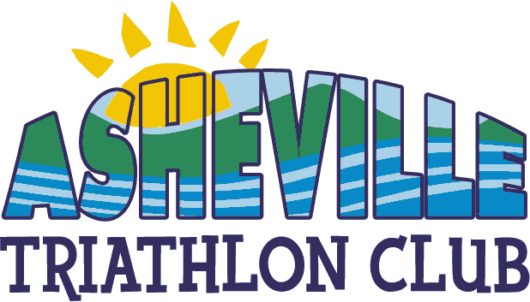
T r i a t h l o n

Saturday – August 30th, 2003
Biltmore Lake – Asheville, NC
Swim .75k Bike 20k Run 5k

Swim - .75k
750 meter freshwater swim in Biltmore Lake. Race morning water temperature will dictate wetsuit legality under USAT rules but, they will more than likely be legal. Wave starts by age groups.

Bike – 20k
20 kilometers of rolling hills through the rural Asheville countryside. A challenging all paved route with no “heart-breaking” climbs. The course is entirely on 2-lane country roads in the shadow of Mt. Pisgah and near Pisgah National Forest.

Run – 5k
5 kilometers of relatively flat, shady woodchip trails circling Biltmore Lake. An aid station will be available at the halfway point.

Awards
Cash awards will be presented to the Overall top-3 males/females and Overall Masters male/female. Distinctive awards will go to the top 3 in 10 age groups male/female. Distinctive awards will also go to the top 3 Clydesdale (200+lbs) and Athena (145+lbs) finishers as well as the Overall male, female and coed relay.

Lodging
There are many lodging opportunities in and around Asheville. For one of the finest, visit: www.biltmore.com

Amenities
A safe, well-managed USAT certified course with all participants receiving a synthetic performance T-shirt with race logo as well as a race “goodie bag” and post race awards ceremony with refreshments.

Travel
The race site is located about 8 miles west of downtown Asheville at the Biltmore Lake Club. From exit 44 off of Interstate 40, take Hwy 19 west to Sandhill Rd. Turn left on Sandhill Rd. and proceed through one traffic light before looking for parking directors on the left in the BASF plant parking lot across from Enka Lake Rd. Park and proceed 400 meters up Enka Lake Rd. to the race site.

Entry Fees
Individual -$45 USAT member ($54 non-USAT)
Relay - $75 USAT members ($84 if anyone on the team is NOT a USAT member)
Late registration fee - $5 extra for registrations postmarked after 8/15/03

Field limit of 400 – This race promises to be popular and may fill quickly!
Please see www.main.nc.us/tca/ for more information. Or call 828-255-9860
Email contacts - mike@racedayevents.net and curwen@bellsouth.net

Entry Form
Enter on Active.com as well

USAT#
Champion chip #
Name
Address

City State
Zip
Country
Daytime phone
Age on Race Day Sex
Synthetic T-shirt size S M L XL
E-Mail Address

Elite Age Group
Clydesdale/Athena Relay
Relay team Name

Make Checks payable to:

Triathlon Club of Asheville
17 Southwicke
Arden, NC 28704

No Refunds. I agree to sign applicable waivers at event.

Signature____________________________________
.

T r i a t h l o n

Saturday – August 30th, 2003
Biltmore Lake – Asheville, NC
Swim .75k - Bike 20k - Run 5k
8:00 AM

Presented by:

Biltmore Farms, Inc.

Sponsor

Sponsor

Timing provided by:
www.racedayevents.net

