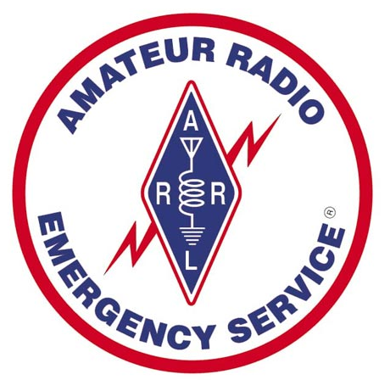

MITCHELL COUNTY

ARES

EMERGENCY HANDBOOK

Revised 2/6/2008

Table of Contents

page
Scope……………………………………………………………..…………….………………………………………………………………….4

Definitions…………………………………………………………………..…………………………………………………………………..4

Membership……………………………………….….……………………………………………..…………………………………………4

Activation Information………………………………………………………………………..……..……………………………………4

Net Control…………………………………………………………………………………………………………….………………………….5

Activation Levels & Definitions…………………………………………………………………………………………..……………6

Frequencies……………………………………………………………….………………………………………………………………………7

Operations………………………………………………………………………………………………………………………….………….…8

Preparedness………………………………………………………………………………………..………………………..……………….9

Training………………………………………………………….……………………………………………………………………………..…9

Served Agencies, Deployment Points, Shelters, Addendum 1………………………………….…………………11

Avery, Yancey, McDowell Locations, Addendum 1 (cont)……………………………....………………………….13

Local Repeaters. In. out, linkages, Addendum 2……..……………………….……………………………………..…14

Half-Duplex Cross-Band Ops, Addendum 3……………………………………………………….……………………..…15

Full Duplex Cross Band Ops, Addendum 4…………………………………………………………………………………….17

Net Log Blank Form, Addendum 5……………….…………………………………..……………………………………….…19

“GO Kit” Ideas, Addendum 6………….……………………………………………………………..……………………………...20

Station Equipment/Supply Ideas, Addendum 7………………..……………………………………..……………………21

First Aid Kit Suggestions, Addendum 8………………………………….……….……………………………………………22

Other equipment Suggestions, Addendum 9……………………………..…………………..……………………………23

Crisis Relocation, Addendum 10. ………………..……………….…..………………………………………………………..24

Bug-Out Kit, Addendum 11……………..…………………………………….…………………………………………………….24

W1AW (ARRL) Frequencies and Info, Addendum 12……………..…….………………………………………………25

RACES Frequencies/Bands/Info, Addendum 13………………………..….……………………………………………..26

Area Repeater List, Addendum 14………………………………………..……………………………………………………..27

Emergency Operations

Scope:
This plan provides guidelines for providing communications support during and after a disaster or emergency situation in Mitchell County, NC. or surrounding areas.

I. Definitions:

A. Confined area disaster:

An event that encompasses a limited area, up to Several city blocks. Although the disaster area may be small,
Communications may be needed at other sites.

B. Large area disaster:

An event encompassing a large geographical area, possibly the entire county, or more.

C. What is ARES?

ARES is the Amateur Radio Emergency Service, and is part of the ARRL Field Organization. ARES is tasked with providing backup and emergency Communications for our primary and secondary served agencies.

D. What is RACES?

RACES is the Radio Amateur Civil Emergency Service. It is a joint effort of both Amateur Radio and Emergency Management agencies. Its focus is primarilyCIVIL DEFENSE related. At present there is no RACES group or operation in Mitchell County.

Some of the information in this handbook is from government and other sources. ARES is the copyright of ARRL. This handbook is to be considered as providing operational guidelines for the Mitchell County, NC Amateur Radio Emergency Service (ARES). It is a work-in-progress and may be updated at any time as the need arises. Other protocols may be used on a case-by-case basis as the need dictates. Most of the information in this handbook is stuff that we hope we rarely have to use, but...

II. Mitchell County ARES Membership List

A complete list of the Mitchell County ARES Members can be found at

www.main.nc.us/maraclub

III. Activation Information

A. Activation of this plan shall be made by the EC, AEC or a designee upon request of one or more of its client agencies. Which include:

Mitchell County Emergency Operations Center (EOC)
Red Cross
North Carolina State Emergency Response Team (SERT)
Amateur Radio Emergency Service (ARES)
National Weather Service (NWS)
Sheriffs Dept
SKYWARN
Mutual Aid (Other ARES RACES)

B. The ARES EC or AEC may utilize the following methods to establish ARES activation in support of NC State or local EOC emergency communications:

1. Announcement on local repeaters.
The main VHF repeater for Mitchell County ARES is Iowa Hill, Spruce Pine - 146.895 + PL 123.0.
In the event 146.895 is not available, Woodys Knob, Spruce Pine - 443.925 + PL 123.0 will be the secondary repeater.
Third level backup is Mt. Mitchell – 145.190 – No Tone. In the event no repeaters are available, tune to 146.520 simplex.
2. Announcement will also be made on HF 3923 KHz (LSB) and/or 7232 KHz (LSB), depending on availability of operators and conditions.
3. Announcement by phone.
4. Announcement by email (includes text pagers and SMS capable devices).

IV. Net Control:

A. A Net control station (NCS) may be appointed by the Emergency Coordinator, Assistant Emergency Coordinator, District Emergency Coordinator, or another EC in the affected area. . All communication will be routed through the NCS station on the net frequency. The NCS station should be located outside the affected area if possible and should not be involved in the emergency. The NCS should be as much as possible self sustaining with respect to electrical power, manpower, area and commercial communications and life support. The NCS should appoint a station designated as a backup NCS to be available to take over as NCS should it become necessary

B. ARES member activities:
During a disaster situation, individual members available for assignment will be identified by the NCS and assigned as necessary. ARES volunteers may be assigned directly to the disaster site or to a staging area by the NCS. If assigned to the disaster site, volunteers should check in, in person, with the Incident Commander. All ARES volunteers assigned either to the disaster site or to the staging area should have in their possession an ARES/Mitchell County Identification Card. This ID card is required for entry into EOCs and event area. In order to avoid the added confusion of unnecessary and unauthorized personnel on the scene, only those volunteers assigned directly to the disaster site or staging area(s) should go there. Once on the disaster scene, individual ARES members should identify themselves to the on-scene CP for assignment. All volunteers should be equipped with portable radios capable of operation on all 2 Meter frequencies. Members should also have available mobile units, magnetic mount antennas and extra batteries. ARES members may be asked to provide communications between the disaster site and support sites such as hospitals, staging areas or client agency command centers. All such traffic must be “plain text” authenticated by the agency official that originates the message and takes responsibility for it. All traffic must be routed through the NCS. In all instances the mission of ARES is to provide communications support to client agencies. ARES members should undertake no actions other than this primary mission unless specifically requested by the client agency. Communications is our only job, not firefighting, law enforcement, first aid or anything else. Clear all non-communications assignments with the EC or assistant EC. While a disaster situation may require the taking of certain calculated risks in order to accomplish the mission, ARES members are responsible for their own safety and should take no action that places them in personal jeopardy. In a questionable situation, pull back and report your situation to the NCS, EC or AEC.

V. Activation Levels & Definitions

The following Activation Level definitions will allow for a structured unified response to emergency situations for Mitchell County and the State of North Carolina, Dept. of Emergency Management (NCEM) http://www.dem.dcc.state.nc.us/index2.htm, while providing support for civilian agency activities during emergency situations. This plan is modeled on the NCEM Emergency Operations Plan. It is not necessary for activation levels to occur sequentially, increasing or decreasing levels. It is the responsibility of the EC’s to coordinate with NCEM and apply the Activation Level necessary to provide support.

A. Activation Level 4 – Standby:

This level of activation is to raise the awareness of ARES volunteers and to provide advance notice in order for them to prepare for a possible deployment. There is no requirement for a net to be established at level 4. Volunteers should monitor their radios if possible (see frequencies below) and check their level of preparedness. Below are some examples:

Check family members
Check schedule and availability
Check batteries (and generator if owned)
Check ‘Go Kit’
Fill gas tank, including generator(s) Etc.

“A level 4 activation notification message will take the following format: ARES Level 4 Stand By Activation has been established by (EC name) to support the NC State EOC at (time and date). All ARES volunteers are asked to check preparations and listen to ARES EOC frequencies. Thank you for your support.” (Additional information if available).

B. Activation Level 3 – Minimal Deployment

At this level of activation ARES ECs shall assess the need for volunteers. ECs may contact minimal numbers of ARES members to gather scheduling information. There is no requirement for a net to be established at level 3, however if the ECs feels a net is required, they may call for Net Control Station (NCS) volunteers. Liaison station support may also be established. If deemed necessary the ECs may conduct equipment testing including possible testing at the EOC. Volunteers should monitor their radios if possible (see frequencies below) and check their level of preparedness.

A level 3 activation notification will take the following format:

“An ARES Level 3 Minimal Deployment Activation has been established by (EC name) to support the NC State EOC at (time and date). All ARES/RACES volunteers who are available are asked to standby and be ready for an assignment. All available operators are asked to listen to ARES/RACES State EOC frequencies as outlined above. Please stand by for additional information. Thank you for your support.”

C. Activation Level 2 – Moderate Deployment

At this level of activation at least one ARES EC/AEC shall be deployed
at the EOC. ECs shall start the call up tree for ARES members to establish a 72 hour schedule.

There is a requirement for a net to be established at level 2 and the EC/AEC shall establish a schedule for Net Control Station (NCS) volunteers.

Volunteers should monitor their radios (see frequencies below) and be ready to react to calls for service at the EOC or elsewhere.

A level 2 activation notification will take the following format:

“An ARES Level 2 Moderate Deployment Activation has been established by (EC name) to support the Mitchell County EOC at (time and date). All ARES volunteers are asked to be ready for an assignment and listen to ARES frequencies. The call up list has been activated. Please stand by for further information. Thank you for your support.”

D. Activation Level 1 – Massive Deployment

At this level of activation EC/AEC schedules are updated to fulfill operator and net control requirements for up to two weeks. All ARES resources shall be available to support NCEM and other served agencies. All nets and sub-nets shall observe strict net protocols until the Activation Level 1 is rescinded.

A level 1 activation notification will take the following format:

“An ARES Level 1 Massive Deployment Activation has been established by (EC name) to support the Mitchell County and State EOC at (time and date). All ARES volunteers are sked to be ready for an assignment and listen to 147.895 for further information. Please ensure your family is secure before applying for a schedule slot.”

VI. FREQUENCIES (VOICE)

MITCHELL COUNTY
146.895 + PL 123.0 (Iowa Hill, Spruce Pine)
is the primary emergency repeater for Mitchell County. This repeater should be monitored first in the event of an activation, severe weather, or disaster. This repeater may also be used by McDowell County during ARES activation. This repeater is normally linked to Woodys Knob.

443.925 + PL 123.0 (Woodys Knob, Spruce Pine) is the first backup repeater for Mitchell County ARES.

145.190 – No Tone (Mt. Mitchell) is the Mitchell County ARES second backup repeater.

146.520 no tone, is the first Mitchell County simplex and National Simplex Calling Frequency.
146.500 is the second Mitchell County ARES simplex frequency.
146.550 is the third Mitchell County ARES simplex frequency.

McDOWELL COUNTY
146.985 PL 118.8 is the McDowell County primary backup repeater.
444.125 + PL 162.2 is the McDOwell County secondary backup repeater
???.??? is the McDowell County ARES primary Simplex frequency.
???.??? is the McDowell County ARES secondary simplex frequency

This is not a complete listing of all the repeaters in the area. Consult the McDowell ARES website & the addrndums at the end of this document for further information. Remember: other repeaters can be pressed into emergency service if needed.

Do not count on a particular repeater being available. Even some of the repeaters with backup power failed during the December 2002 ice storm.

NC & NATIONAL FREQUENCIES
3.923 (LSB) is the Morning / Night primary for the Tarheel Emergency Net.
7.232 (LSB) is the Day primary for the Tarheel Emergency Net.
3.935 (LSB) is designated for NC State RACES primary use if frequency
restrictions are invoked.
7.250 (LSB) is designated for NC State RACES secondary use if frequency restrictions are invoked.
14.340 (USB) is designated for NC State RACES tertiary use if frequency
restrictions are invoked.

3.938 (LSB) is the North Carolina Single Sideband Net. This frequency
may be pressed into service in the event of a National Emergency.

VII. FREQUENCIES (DATA)

It is expected that Winlink2000 Airmail will be utilized for all data transmissions. Connection shall be made using the most expedient means available to pass the required traffic. This will usually mean using the local Telpac relay stations, if available. Peer-to-Peer connections may also be utilized. Coordination and utilization will be determined on a case-by-case basis.

VIII. OPERATIONS

If you become aware of a potential situation that may require an ARES
activation, immediately monitor the ARES repeaters in the following order: 146.895, 443.925, 145.190. Do not wait for a call-up or e-mail notification.
If you hear no traffic after a few minutes, transmit your call sign and see what happens.

If the ARES net is brought up on a standby mode, regular traffic is permissible. However, ARES traffic has priority over normal traffic. Longer breaks between transmissions are required, and transmissions should be shorter than normal. If possible, long ragchew traffic should be moved to another repeater or simplex.

If the ARES net is in an active mode, regular traffic will be severely limited. ARES and Skywarn traffic has priority. A Net Control Station will be on air, and almost all traffic should go through that station. Longer breaks between transmissions are required, and transmissions must be shorter than normal, to allow for emergency and priority traffic to be passed rapidly. Ragchew and other non-germane traffic should e moved to another repeater or simplex.

If a served agency or other contacts you requesting Amateur Radio support for an event or emergency communications backup, take down as much information as possible, then immediately notify the Emergency Coordinator(s) of the request. The reason for this is to make sure that all requests are routed as quickly as possible to the appropriate support group.

If the situation warrants, move point-to-point and ragchew traffic to other repeaters, or if in range, a simplex frequency such as 146.520, 146.500 or 146.550 MHz (remember to open your squelch).

As part of mutual aid understanding and agreements, Mitchell County ARES may be requested to assist McDowell or Avery County should the need arise. Familiarity with locations in the areas will be very beneficial.

REMEMBER: In an emergency, our frequencies may be monitored by the public, served agencies, and the news media. IT IS VITAL that all ARES operations be conducted as friendly, courteously, and as professionally as possible. Regardless of what some people may think, we ARE an emergency service. Our actions reflect on all Hams, and to a point, on other emergency services.

IX. PREPAREDNESS

A. Preload all of your radios with the repeater frequencies and PL tones for your area, as well as some of the wide area repeaters outside of your normal area. Using your main VHF/UHF antenna, try to activate each of your area repeaters so that you know which repeaters you can actually use, and verify the settings for each repeater.

B. Have an inside VHF/UHF antenna that can be used for storms. If possible, it should be mounted as high as possible inside the attic. Test this antenna so that you know which repeaters you can use with it. Periodically use this antenna instead of the main station antenna to detect problems before the storm antenna is needed.

C. Determine your station’s simplex range. A rough idea can be determined during repeater nets by switching between the input and output frequencies, and noting which stations can be heard on the input. Range will be determined by terrain, antenna heights and gains, and transceiver output power.

D. Keep your station at a level of readiness at all times, even if it means connecting a handheld radio to the main station antenna. You will be surprised what 5 watts can do with a decent antenna.

F. If your station uses 12 VDC as the main working voltage, and your backup wet cell battery is outside, periodically clean the battery connections and tighten them. A poor connection will reduce the amount of power available to the station during a power failure or dangerous operating conditions.

G. Experiment to determine how little power is required from your main radio and antenna to achieve full quieting on the county emergency repeaters, and your favorite repeaters. Reduced transmit power will lengthen your available equipment operating time during power outages.

H. Construct one or more twin lead “expedient” and/or expendable J-pole antennas. These are for use in case the main station antenna fails.

X. Training

A. Weekly ARES training nets meet on the 146.895 + PL 123.0 Iowa Hill repeater on Wednesday at about 8:30 pm (20:30) Eastern Time.

B. We will participate in ARES formal training events, (ie, November SET, State & Local County drills, and other formal simulations & exercises).

C. Participation in Public Service events can provide many needed skills and practice for emergency communications

D. Red Cross First Aid/CPR certification (and renewal) can make you amore valuable volunteer, and possibly save a life!

E. Obtain the ARRL ARES Field Resources Manual

F. Experiment with Simplex operations in our area.

G. We expect to Participation in Skywarn nets and operations.

See Addendum 1 and up for Served Agencies and other related helpful information

Addendum 1
MITCHELL COUNTY SERVED AGENCIES (SA)/POSSIBLE DEPLOYMENT POINTS (DP)/SHELTERS (S)
Item | Facility | 911 Address | City | Phone | Code | Lat | Long | Alt
EOC | Mitchell EOC | 47 Crimson Laurel Cir. | Bakersville | 688-4615 | SA, DP | 36°00’47.73” N | 82°09’15.76”W
 | 911 Communication Center | Behind MC Admin Bldg |  | 688-9110 | SA, DP
Schools | Bowman Middle | 410 N. Mitchell Ave. | Bakersville | 688-2752 | DP, S | 36° 00’ 37.46” N | 82° 09’ 19.85” W | 2499’
 | Buladean Middle | 12190 N. Hwy 226 | Buladean | 688-2324 | DP, S | 36° 06’ 29.09” N | 82° 11’ 38.88” W | 2763’
 | Deyton Primary | 308 Harris St. | Spruce Pine | 765-2504 | DP, S | 35° 54’ 36.01” N | 82° 05’ 02.81” W | 2643’
 |  |  | Lunch Room | 765-9790
 | Greenlee Primary | 2206 Carter’s Ridge Rd. | Spruce Pine | 765-9562 | DP, S | 35° 58’ 13.68” N | 82° 03’ 11.39” W | 2684’
 | Gouge Elementary | 134 Laurel St. | Bakersville | 688-2141 | DP, S | 36° 00’ 52.77” N | 82° 09’ 12.48” W | 2477’
 | Harris Middle | 121 Harris st. | Spruce Pine | 765-2321 | DP, S | 35° 54’ 34.01” N | 82° 05’ 02.81” W | 2643’
 |  |  | Lunch Room | 765-9666
 | Mitchell High | 416 Ledger School Rd | Ledger | 688-4432 | DP, S | 35° 58’ 13.68” N | 82° 07’ 02.77” W | 2803’
 |  |  | Lunch Room | 688-4514
 | Tipton Hill | 4256 NC 197 | Green Mtn | 688-2949 | DP, S | 36° 02’ 05.76” N | 82° 16’ 06.28” W | 2429’
 | Mayland Comm College | 200 Mayland Drive | Spruce Pine | 765-7351 | DP, S
Medical | Bakersville Med Clinic | 86 N. Mitchell | Bakersville | 688-2104 | DP | 36° 00’ 57.27” N | 82° 09’ 25.68” W | 2466’
 | Blue Ridge Regional Hospital | 125 Hospital Way | Spruce Pine | 765-4201 | SA, DP, S | 35° 54’ 40.09” N | 82° 03’ 46.24” W | 2612’
 | Spruce Pine Family Med Ctr | 496 Altapass Hwy | Spruce Pine | 765-0170 | DP
Center | Senior Citizen Center | 152 Ledger School Road | Ledger | 688-3019 | DP, S | 35° 58’ 0.92” N | 82° 06’ 55.82” W | 2745’
 | Brian Center | 218 Laurel Creek Ct. | Spruce Pine | 765-7312 | DP
Law | MC Sheriff | 63 Crimson Laurel Cir | Bakersville | 688-3982 | SA, DP | 36° 00’ 47.17” N | 82° 09’ 14.79” W | 2458’
 | Police – Spruce Pine | 131 Highland Avenue | Spruce Pine | 765-2233 | SA, DP | 35° 54’ 54.37”N | 82° 04’ 24.35” W | 2559’
 | Police - Bakersville | 26 S. Mitchell Avenue | Bakersville | 688-2113 | SA, DP | 36° 00’ 53.71”N | 82° 09’ 30.85” W | 2447”
 | NC Highway Patrol | 106 Highland Ave | Spruce Pine | 765-6220 | SA, DP
Utilities | French Broad EMC (CP&L) |  | Bakersville | 688-4815
 | Progress Energy |  | Spruce Pine | 800-419-6356
 | Piedmont Gas |  | Spruce Pine | 800-356-2593
Item | Facility | 911 Address | City | Phone | Code | Lat | Long | Alt
Gov | Town Hall – Spruce Pine | 106 Highland Avenue |  | 765-3000 | SA, DP
 | Town Hall - Bakersville | 26 S. Mitchell Avenue |  | 688-2113 | SA, DP
 | Mitchell County Admin | County Admin Bldg | Bakersville | 688-2139 | SA, DP
 | NC Forest Service | 125 Forest Service Rd | Ledger | 688-9405 | SA, DP
 | Nat Park Service - Ranger | 133 Pkwy Maintenance Rd | Spruce Pine | 765-6052 | SA, DP | 35° 51’ 16.88” N | 82° 03’ 08.85” W | 2813’
 | Nat. Park Service - Maint | 214 Pkwy Maintenance Rd | Spruce Pine | 765-9266 | SA, DP | 35° 51’ 19.2” N | 82° 03’ 12.72” W | 2815’
FIRE | Altapass FD | 3452 Altapass Hwy | Spruce Pine | 765-0088 | SA, DP, S
 | Bakersville FD | 306 Baker Lane | Bakersville | 688-4794 | SA, DP, S | 36° 00’ 47.03” N | 82° 09’ 44.94” W | 2443’
 | Buladean FD | 12190 Hwy 226 N | Bakersville | 688-2324 | SA, DP, S | 36° 06’ 30.60” N | 82° 10’ 41.11” W | 2776’
 | Estatoe FD | 1126 Hwy 19 | Spruce Pine | 765-6163 | SA, DP, S
 | Fork Mountain FD | 2525 Fork Mountain Rd | Bakersville | 688-4794 | SA, DP, S | 36° 03’ 06.30” N | 82° 10’ 42.84” W | 2772’
 | Parkway FD – Grassy Creek | 12966 Hwy 226 S. | Spruce Pine | 765-2117 | SA, DP, S | 35° 52’ 55.04” N | 82° 03’ 29.04” W | 2618’
 | Spruce Pine FD | 131 Highland | Spruce Pine | 765-2233 | SA, DP, S | 35° 54’ 54.37”N | 82° 04’ 24.35” W | 2559’
 | Ledger EMS | 5165 S. 226 Hwy | Bakersville | 688-9072 | SA, DP, S | 35° 57’ 53.75” N | 82° 06’ 54.93” W | 2717’

Addendum 1 (Cont) Avery, Yancey, McDowell Emergency Locations

Item | Facility | 911 Address | City | Phone | Code | Lat | Long | Alt
EOC | Avery County EOC | 175 Lineville St. | Newland | 733-8210 | SA | 35°05’ 01.67” N | 81° 55’ 21.56” W | 3599’
 | McDowell County EOC | 41 S. Garden St. | Marion | 652-7121 | SA | 35°41’ 02.04” N | 82° 00’ 27.43” W | 1400’
 | Yancey County EOC | 15 East Blvd | Burnsville | 678-9266 | SA | 35°54’ 58.09” N | 82° 17’ 43.6” W | 2728’
 | McDowell AmateurRadio Assoc. | N. Garden St. | Marion |  | SA, DP | 35°41’ 05.77” N | 82° 00’ 30.41” W | 1401’
LAW | Burnsville Police | 2 Town Square | Burnsville | 682-4683 | SA | 35° 55’ 0.72” N | 82° 17’ 58.16” W | 2809’
 | Marion Police | 270 S. Main | Marion | 652-3231 | SA | 35° 40’ 49.25”N | 82° 00’ 26.34” W | 1382’
 | Avery County Sheriff | 300 Schultz Circle | Newland | 733-5855 | SA
 | McDowell County Sheriff | 270 S. Main | Marion | 652-4000 | SA | 35° 40’ 49.25”N | 82° 00’ 26.34” W | 1382’
 | Yancey County Sheriff | 1 East Main | Burnsville | 682-2124 | SA | 35° 55’ 01.86”N | 82° 17’ 56.56” W | 2807’
 | NC Highway Patrol – Yancey | 116 N. Main | Burnsville | 682-2579 | SA
 | NC Highway Patrol – McDowell | 3975 NC Hwy 226 | Marion | 652-2181 | SA
 | NC Highway Patrol – Avery | 301 Cranberry Street | Newland | 733-0489 | SA

Addendum 2 Related Information 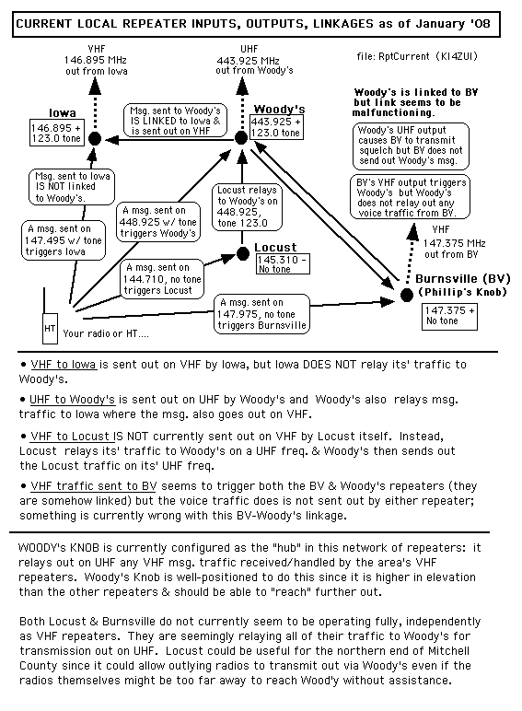

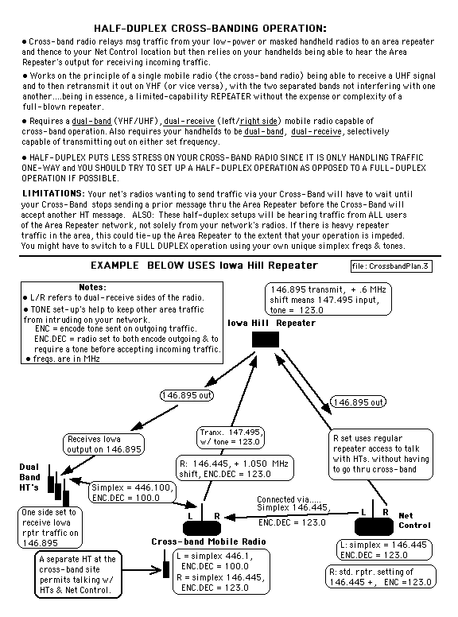
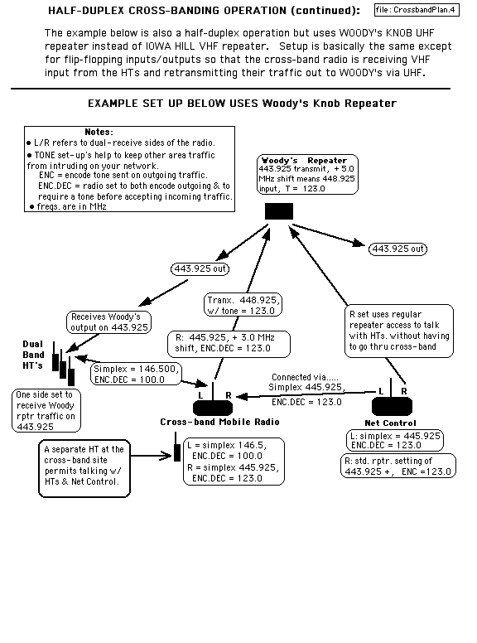
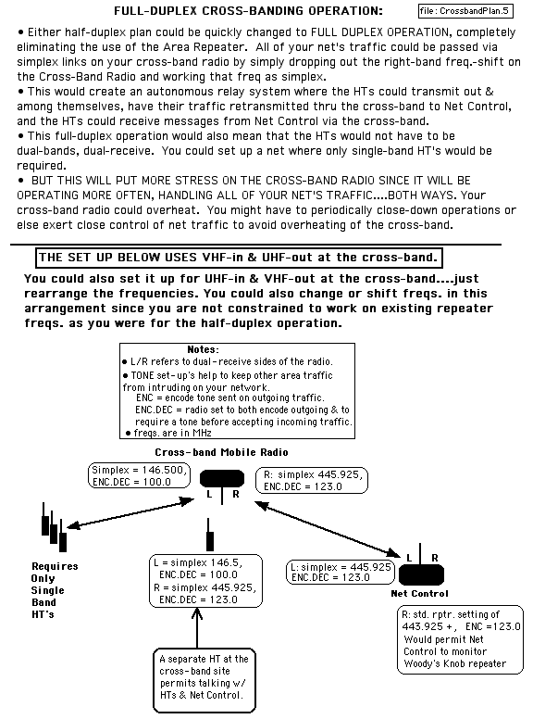

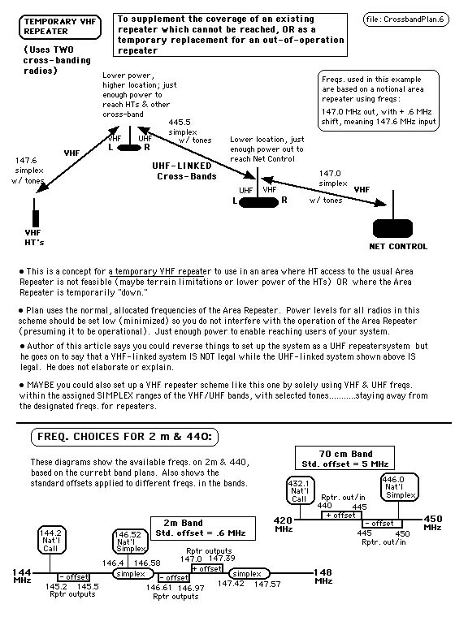

Addendum 5

Mitchell County
ARES
Net Log

NCS Call sign: ___________________
Date: ___________________________
Time start: _______________________
End Time: _______________________
Total Net Time: ___________________
Type of Net: ______________________ (Weekly, Drill, Emergency or Other please state)

CALL NAME LOCATION IN OUT FORMAL TRAFFIC MOBILE ECHOLINK

- __________________________________________________________________________________________
- __________________________________________________________________________________________
- __________________________________________________________________________________________
- __________________________________________________________________________________________
- __________________________________________________________________________________________
- __________________________________________________________________________________________
- __________________________________________________________________________________________
- __________________________________________________________________________________________
- __________________________________________________________________________________________
- __________________________________________________________________________________________
- __________________________________________________________________________________________
- __________________________________________________________________________________________
- __________________________________________________________________________________________
- __________________________________________________________________________________________
- __________________________________________________________________________________________
- __________________________________________________________________________________________
- __________________________________________________________________________________________
- __________________________________________________________________________________________
- __________________________________________________________________________________________
- __________________________________________________________________________________________
- __________________________________________________________________________________________
- __________________________________________________________________________________________
- __________________________________________________________________________________________
- __________________________________________________________________________________________
- __________________________________________________________________________________________

*Remember to pass the final Net Report as a formal message to the EC.
NOTES:

Addendum 6 GO Kit ideas

1. A Handheld radio, preferably true dual band (able to receive two stations simultaneously on the same or different bands - VHF/UHF). Minimum power output of 5 watts.
2. Photocopy of the radio’s manual.
3. Extra batteries and/or a dry cell converter with dry cell batteries.
4. Photocopy of your current FCC Amateur license.
5. Higher gain “rubber duck” antenna(s) for your handheld radio(s)
6. Counterpoise for handheld radio long enough for the lowest frequency that you
can transmit on.
7. Expedient J-pole (300 ohm twin lead) or other antenna, and support hardware.
8. Reasonable length coax cable with connectors installed.
9. BNC to SO-239 or SMA to SO-239 adapters, depending upon the handheld
radio(s).
10. Combination speaker/mic for the handheld radio.
11. Headset, headphones, or earphone for the radio(s) to be used.
12. DC “car” adapter or AC adapter/charger for the handheld radio(s)
13. Aspirin and/or other pain reliever.
14. Several doses of any prescribed medication you may need.
15. Flashlight and/or small battery powered lantern. (extra batteries, too)
16. Notepads and writing equipment.
17. ARRL Radiogram forms (can be photocopies)
18. One or more folded area maps.
19. Money in small bills and a bit of change.
20. ARRL Repeater Directory.
21. Small hand tools.
22. Large paper clips and rubber bands to suspend coax or a J-pole antenna
from suspended ceilings.
23. Canned water and snacks. Keep these in a closed or sealed plastic bag.
24. A flattened roll of toilet paper
25. Waterless hand cleaner or a few sealed handi-wipes.
26. A high quality backpack to put all the above in.
27. A hand held GPS, if available
28. A compass

Addendum 7 Station emergency equipment and supply Ideas

Enough bottled water for at least 4 days for your household and guests. 1 gallon minimum per person, per day. Include extra water for cooking purposes. Enough for each person for at least 4 days. This food should be the same or similar to the regular diet, but require less or no preparation, and no refrigeration. This includes: ready-made canned foods, crackers, cookies,
instant noodles, sugar, salt, chocolate and/or other candy, raisins or other dried fruits, and powdered or UHT (long-life) milk. Don’t forget the soft drinks, coffee, and tea!
Heavy paper plates (Chinet), paper cups, and plastic cutlery and utensils.
One or preferably two manual can openers.
Water purification tablets or bleach without any additives.
Britta or equivalent water filtration device.
Paper towels, Toilet paper, feminine supplies, plastic garbage bags.
One or two bottles of alcohol based hand sanitizer.
At least 2 flashlights and/or battery powered lanterns (with extra batteries)
A gas fueled camp stove, gas burner, or gas ring. Gas canisters used should be
the type with an internal valve to allow for safer storage by detaching the
canister from the appliance. Avoid those gas appliances that use puncture type
canisters.
Matches and/or lighter (keep well away from children)
An extra propane gas tank for the gas grill, if it doesn’t use piped gas.
At least 1 dry chemical fire extinguisher, rated at 3-A 40-BC or better. It must
have a metal valve assembly, not plastic.

Adapters for all handheld radios to allow them to be connected with the main station antenna.
At least one 12 volt deep cycle (preferred) or auto battery, and cabling with
connectors to run the station with.
Extra batteries and/or a dry cell converter.
An expedient j-pole or other antenna, and a barrel connector. (to replace the
station antenna if it becomes damaged or unusable, or for use with handhelds)
Combination speaker/mic for the handheld radio(s).
A reasonable length of small gauge wire to make counterpoises for the
handheld radios, each long enough for the lowest frequency that can be
transmitted upon. (It CAN make a difference)
A reasonable length of 12 to 16 gauge insulated wire, insulators, and lightweight
rope for a temporary HF antenna if you are licensed for HF, or wish to monitor
HF frequencies.
A small set of hand tools.
2 sets of heavy work gloves.
A gas or other soldering iron that can run on something other than 120 VAC.
Rosin core solder.
Plastic sheeting (for damage control and/or Shelter In Place use)
Duct tape
Masking tape, wide width (aprox 2 in / 5 cm)
Electrical tape

A reasonable sized first aid kit (see addendum 8, below)

Some means of generating AC power. This can be a generator and/or inverter.
Additional fuel for the generator and/or vehicle.

Addendum 8 First Aid Kit Suggestions

Manuals--Red Cross First Aid Manual
-American Medical Association Handbook of First Aid and Emergency
Care (recommended)

Medications Aspirin,
300 mg tablets
Ibuprofen, 200 mg tablets (Advil, Motrin, etc.)
Ammonia inhalant, 10 cnt.
vaseline or A & D ointment, 2 oz tube
Sodium Chloride tablets, 1 g
Laxative-Antacid (Milk of Magnesia, etc.)
Phosphorated Carbohydrate solution (for nausea/vomiting)
Betadine solution, 8 oz bottle
Alcohol swabs, 20 cnt.
Small bottle hydrogen peroxide
Lomotil (or equivalent) for diarrhea
PLUS ANY PERSONAL MEDICATIONS YOU OR YOUR FAMILY MEMBERS MAY NEED

Bandages Plastic
strips, 3/4" wide, 20 count
Plastic strips, 1" wide, 20 cnt.
Butterfly closures, 20 cnt.
Gauze pads, 2" x 2", 10 cnt.
Gauze pads, 4" x 4", 10 cnt.
Gauze pads, Eye pads, 5 cnt.
Adhesive pads, 2" x 3", 10 cnt.
Surgical sponge dressings, 4" x 4", 10 cnt.
Surgical sponge dressings, 5" x 9", 10 cnt.
Flexible gauze ("Kling" type), 2" x 5yds, 2 cnt.
Flexible gauze ("Kling" type), 4" x 5yds, 2 cnt.
Triangular bandage

Misc. Equipment Medical
tape, 2 rolls
Tweezers
Hemostats, straight, 9"
Hemostats, curved, 9"
"E.M.T." Shears
Finger splints - 1ea, small, med., large
Rescue Breather w/ one-way valve
Rubber (or equivalent) Gloves, 5 sets
Small bottle of hand sanitizer (alcohol based)
Penlight - extra batteries
Matches
Foil "space" blanket, 2 cnt.

Diabetic Kit -Glucose
tablets, 5 g, 5 count
Syringe, disposable, 1 cc, 10 cnt.
Lance and Lancet system (for blood sampling)
Test strips for blood sugar
Reagent strips for Urinalysis

Bee Kit -Antihistamine
Tablets 1/1000 Epinephrine Syringe, disposable, 1 cc, 10 cnt. Tourniquet

Addendum 9 Other equipment ideas and suggestions

Have a DC/Car Charger for the handheld transceivers you might own.
Have a DC/Car Adapter for each model cell phone(s) you may own.
Have a dry cell adapter for the handhelds you may own, with batteries.
Keep an expedient j-pole antenna in your vehicle’s trunk with needed
adapters for your handheld radio(s)

Addendum 10 Crisis Relocation (Evacuation, Bug-Out, Run-For-It!, etc)

If you live or work in an area that is a higher risk for evacuation, such as the
coastal areas, chemical plants, and Nuclear Power Plant EPZs:

1. Preload all your radios with amateur radio repeaters for the counties you might evacuate to, National Calling Frequencies of 146.520 and 446.000, and the common simplex frequencies used in those counties. (This is in addition to the normal frequencies that may already be programmed.)

2. Keep a CURRENT copy of your FCC Amateur License in the vehicle.

3. Keep a current copy of the Repeater Directory, in each vehicle.

4. Keep with you a handheld radio, preferably true dual band with a minimum power output of 5 watts.

5. Keep a photocopy of the radio’s user manual(s) in the vehicle.

6. Keep a CURRENT copy of the state highway map in the vehicle.

7. Know the primary and backup operating frequencies of the ARES groups in the areas you might evacuate to.

8. Keep enough small gauge wire in the vehicle to construct counterpoises for each of your handheld radio(s), for the lowest frequency you can transmit on.

9. Construct and keep in the vehicle a portable (twin lead or ladder line construction) 2 meter J-pole antenna with at least 10 feet of coax, and temporary mounting hardware such as suction cups, string, and paper clips.

10. Keep adapters and enough extra coax so a handheld radio can be used with the mobile antenna and/or the expedient J-pole antenna.

11. Have a dry cell adapter for the handhelds you may own.

12. Keep a DC/Car adapter/charger in the vehicle for the handheld transceiver(s) you might own.

13. Have a DC/Car Adapter for each model cell phone(s) you may own. Note: Some powered hands free units will also charge the cell phone.

14. Keep at least one ruggedized flashlight in the passenger compartment.

15. Keep at least one pair of heavy work gloves in the vehicle.

16. Keep a small stash of cash somewhere in the car, both bills and coins. (if possible, put some of it somewhere besides the glove box) If you are forced to evacuate your residence, after you arrive at your temporary accommodations, take the time to inform Mitchell County ARES of your location and situation. If you cannot make direct contact with either Mitchell or State ARES, send a radio telegram with Welfare priority. Either way, we’ll know that you’re ok.

Addendum 11 Bug-out Kit ideas

A Handheld radio, preferably true dual band / dual receive (able to receive two
stations simultaneously on the same or different bands - VHF/UHF). Minimum power output of 5 watts. Other radio equipment, but only if you have time to retrieve it!!!

1. Photocopy of the radio’s manual(s).
2. Higher gain “rubber duck” antenna for your handheld radio.
3. Battery case (uses AA cells) for the radio, or a 12-volt battery pack and a DC
adapter for the handheld radio.
4. Counterpoise for handheld radio long enough for the lowest frequency that you
may transmit on.

Two sets of clothing for each person.
Two blankets or a sleeping bag for each person
Toilet articles (including feminine articles if needed)
Bath towels
Necessary medication (includes aspirin or ibuprofen)
Baby needs and identification
Car registration (Should already be in the car!)
Some cash in smaller bills and coins.
Checkbook and credit cards.
A battery or generator (hand crank) powered AM/FM radio.
At least one pair of heavy work gloves.
Flashlight with extra batteries.
Legal documents, but only if you have time to retrieve them.
One meal’s worth of food. DO NOT bring food if the evacuation is due to a
Radiological, Nuclear, Chemical, or Biological incident. This is to prevent ingesting anything contaminated.

ADDENDUM 12 W1AW (ARRL) FREQUENCIES and INFO

In a communications emergency, monitor W1AW for special bulletins as follows:
voice on the hour, teleprinter at 15 minutes past the hour, and CW on the half
hour.

Voice Frequencies are 1.855, 3.99, 7.29, 14.29, 18.16, 21.39, 28.59 and

147.555 MHz.
Teleprinter Frequencies are 3.625, 7.095, 14.095, 18.1025, 21.095, 28.095 and

147.555 MHz. Bulletins are sent at 45.45-baud Baudot and 100-baud AMTOR,
FEC Mode B, 110-baud ASCII will be sent only as time allows.
Code Frequencies are 1.818, 3.5815, 7.0475, 14.0475, 18.0975, 21.0675,
28.0675 and 147.555 MHz. Code bulletins are sent at 18 wpm.
Further information can be found on the web at http://www.arrl.org/w1aw.html

ADDENDUM 13 RACES FREQUENCIES / BANDS / INFORMATION

These bands are set aside for RACES use in the event RACES is activated at a
NATIONAL level. Frequencies are in MHz.

Band (meters) | Frequency Range | Frequency Range | Frequency Range
160 | 1.800-1.25 | 1.975-2.000
80 | 3.50-3.55 | 3.93-3.98 | 3.984-4.000
40 | 7.079-7.125 | 7.245-7.255
30 | 10.10-10.15
20 | 14.047-14.053 | 14.22-14.23 | 14.331-14.350
15 | 21.047-21.053 | 21.228-21.267
10 | 28.55-28.75 | 29.237-29.273 | 29.450-29.650
6 | 50.35-50.750 | 52.000-54.000
2 | 144.50-145.71 | 146.000-148.000
1.25 | 222.00-225.000
70 Centimeters | 420.00-450.000
23 Centimeters | 1240.00-1300.00
12 Centimeters | 2390.00-2450.00

The frequencies of 3.997 and 53.300 MHz (fm) may be used in emergency areas when required to make initial contact with a military unit and for communications with military stations on matters requiring coordination.

NATIONAL EAS Activation should be considered as a “heads up!” that a National level RACES activation is imminent.

RACES uses IMMEDIATE, PRIORITY, and ROUTINE as message priorities, instead of the ARES/NTS priorities of EMERGENCY, PRIORITY, WELFARE, and ROUTINE. Treat IMMEDIATE messages the same as EMERGENCY messages.

Note: If there is NATIONAL LEVEL RACES activation, non-RACES stations may be ordered off the air, and some limitations on registered RACES stations may be imposed.

NC RACES Digital and CW Frequencies

If no restrictions:

Mode Primary Secondary

CW 3573 kHz 3695 kHz

Pactor 3624 kHz 7104 kHz

IF frequency restrictions:

Mode Primary Secondary Tertiary
CW 3535 kHz 7120 kHz 10120 kHz
Pactor 3545 kHz 7104 kHz 10130 kHz

ADDENDUM 14
AREA REPEATERS

Name | Freq. | Set | Tone | Site | Town/City | County | State | Club
IOWA | 146.895 | + | 123.0 | Iowa Hill-KF4GUZ | Spruce Pine | Mitchell | NC
WOODY | 443.925 | + | 123.0 | Woody's Knob-KF4GUZ | Spruce Pine | Mitchell | NC
BNELK1 | 442.175 | + | 203.5 | Sugar Top | Banner Elk | Avery | NC
BNELK2 | 444.400 | + | 103.5 | K4DHT | Banner Elk | Avery | NC
BURNVL | 147.375 | + |  | Phillip's Knb-KD4WAR | Burnsville | Yancy | NC
GRNKNB | 146.955 | - | 127.3 | Green Knb-KD4WAR | Blue Rdg Pkwy | Yancy | NC
MARON1 | 146.985 | - | 118.8 | Grant's Mtn-WD4PVE | Marion | McDowell | NC
OLFORT | 444.775 | + |  | KR4EX | Old Fort | McDowell | NC
MARON2 | 444.125 | + | 162.2 | Grant's Mtn-KI4M | Marion | McDowell | NC
MITCH1 | 145.190 | - |  | Mt Mitch-WA4BVW | Mt Mitchell | Yancy | NC
NEWTN1 | 145.170 | - |  | KZ4B-Anderson Mtn | Newton | Catawba | NC
MITCH3 | 443.600 | + | 114.8 | Mt Mitchell-N4DWU | Yancey | Yancey | NC
MITCH4 | 442.225 | + | 136.5 | Mt Mitchell-N4YR | Yancey | Yancey | NC
MORG1 | 145.210 | - | 94.8 | High Peak, K4OLC | Morganton | Burke | NC
MORG2 | 145.150 | + |  | K4VLY | Morganton | Burke | NC | Western Piedmont ARC
MORG3 | 147.150 | + |  | W4YIU | Morganton | WA4OBC (Clyde) |  | Western Piedmont ARC
HICK4 | 145.490 | - | 94.8 | KF4LUC | Hickory | Catawba | NC
HICK2 | 146.850 | - |  | WA4DSZ | Hickory | Catawba | NC
HICK3 | 147.390 | + |  | AE4OL | Hickory | Catawba | NC
LENOR1 | 147.330 | + | 141.3 | KN4K | Lenoir | Caldwell | NC
SHELB1 | 146.880 | - |  | W4NYR | Shelby | Cleveland | NC | Shelby ARC
SHELB2 | 147.345 | + |  | W4NYR | Shelby | Cleveland | NC | Shelby ARC
CHAR01 | 145.290 | - |  | W4BFB | Charlotte | Mecklenburg | NC | Meckleburg ARC
T-BRIS | 146.700 | - |  | KC4CCB | Bristol | Sullivan | TN
T-ERW1 | 145.250 | + |  |  | Erwin | Unicoi | TN
T-ERW2 | 147.165 | + | 107.2 |  | Erwin | Unicoi | TN
FORST1 | 147.240 | + | 94.8 | KG4JIA | Forest City | Rutherford | NC
CANTN1 | 443.475 | + |  | KE4UIU - Piney Knob | Canton | Haywood | NC
CANTN2 | 146.805 | + | 100? | KG4NC | Canton | Haywood | NC

ADDENDUM 11
Name | Freq. | Set | Tone | Site | Town/City | County | State | Club
 | 441.825 | + | 123.0 | W4ERT | Taylorsville | Alexander | NC
 | 147.195 | + | 94.8 | W4ERT | Taylorsville | Alexander | NC
BREV1 | 147.135 | + |  |  | Brevard | Transylvania | NC
BREV2 | 442.850 | + |  | KA7JXU | Brevard | Transylvania | NC
MARSH1 | 442.000 | + |  |  | Marshall | Madison | NC
MARSH2 | 443.000 | + |  |  | Marshall | Madison | NC
BOONE1 | 147.360 | + | 103.5 | KA4AOK | Boone | Watauga | NC
HENVL5 | 147.105 | + |  | WA4KNI | Hendersonville | Henderson | NC
BOONE3 | 443.575 | + |  |  | Boone | Watauga | NC
WAYNE1 | 147.270 | + |  |  | Waynesville | Haywood | NC
WAYNE2 | 147.390 | + |  | N4DTR - Utah Mtn | Waynesville | Haywood | NC
WAYNE3 | 444.450 | + |  | N4DTR - Utah Mtn | Waynesville | Haywood | NC
FORST2 | 146.670 | - | 156.7 | Cherry Mtn | Forest City | Rutherford | NC
ASHV2 | 146.760 | - | 151.4 |  | Asheville | Bumbcombe | NC
ASHV3 | 146.835 | - |  |  | Asheville | Bumbcombe | NC
ASHV4 | 146.910 | - |  | W4MOE | Asheville | Bumbcombe | NC | WC ARS
ASHV5 | 442.550 | + |  | WA4TOG - High Windy | Asheville | Bumbcombe | NC
ASHV6 | 443.275 | + | 103.5 | KF4TLA | Asheville | Bumbcombe | NC
ASHV7 | 444.900 | + |  |  | Asheville | Bumbcombe | NC
HENVL1 | 146.640 | - |  |  | Hendersonville | Henderson | NC
HENVL2 | 147.255 | + |  |  | Hendersonville | Henderson | NC
HENVL3 | 145.270 | - |  |  | Hendersonville | Henderson | NC
HENVL4 | 444.250 | + |  |  | Hendersonville | Henderson | NC
JohnCty1 | 147.270 | + | 103.5 |  | Johnson City | Washington | TN
JohnCty2 | 146.790 | - |  |  | Johnson City | Washington | TN
JohnCty3 | 442.050 | + | 100.0 |  | Johnson City | Washington | TN
JohnCty4 | 444.100 | + |  |  | Johnson City | Washington | TN
LOCUS | 145.310 | - |  | Locust Knob | Bakersville | Mitchell | NC
APRS-GRS | 144.390 | S | n/a |  | APRS Freq. | --- | --
2mCall | 144.200 | S | n/a | Simplex | Nat'l 2m Call | --- | --
2mSimpx | 146.520 | S | n/a | Simplex | Nat'l 2m Simplex | --- | --
440 Call | 432.100 | S | n/a | Simplex | Nat'l 440 call | --- | --
440Simpx | 446.000 | S | n/a | Simplex | Nat'l 440 Simp | --- | --

ADDENDUM 11
Name | Freq. | Set | Tone | Site | Town/City | County | State | Club
Mc-Fire1 | 155.805 |  |  | Mich. Co. EOC & Fire | Mitchell Co. | Mitchell | NC
Mc-EMS | 155.295 |  |  | Mich. Co. EMS | Mitchell Co. | Mitchell | NC
SP-Hosp | 155.340 |  |  | Spruce Pine Hospital | Spruce Pine | Mitchell | NC
Mc-Shrf1 | 155.835 |  |  | Mitch. Co. Sheriff #1 | Mitchell Co. | Mitchell | NC
Mc-Shrf2 | 154.875 |  |  | Mitch. Co. Sheriff #2 | Mitchell Co. | Mitchell | NC
Mc-Shrf3 | 155.370 |  |  | Mitch. Co. Sheriff #3 | Mitchell Co. | Mitchell | NC
FORST2 | 442.500 | + | 94.8 | KG4JIA | Forest City | Rutherford | NC
T-KX02 | 145.210 | - |  |  | Knoxville | Knox Co. | TN
T-KX03 | 145.330 | - |  | WA4TEM | Knoxville | Knox Co. | TN
T-KX04 | 145.370 | - |  | W4FAR | N. Wilkesboro | Wilkes. | NC
T-KX05 | 145.430 | - |  |  | Knoxville | Knox Co. | TN
SAURA1 | 145.110 | - |  |  | Sauratown Mtn | Stokes | NC
SAURA2 | 145.470 | - |  |  | Sauratown Mtn | Stokes | NC
SAURA3 | 146.790 | - | 107.2 | KG4ASL | Sauratown Mtn | Stokes | NC
CHAR02 | 146.940 | - |  | W4BFB | Charoltte | Mecklnburg | NC
T-KX10 | 147.000 | - | 100.0 | KD4CWB | Knoxville | Knox Co. | TN
NEWTN2 | 147.075 | + | 71.9 | KK4NW | Newton | Catawba | NC
 | 145.470 | - |  |  | Cross Mtn. | Bradley | TN

